**PROJECTBASED CLASS REPORT**

**On**

***EXPERT SYSTEM FOR ORGANIZING CONFERENCES***

**Submitted in partial fulfilment of the**

**Requirements for the award of the Degree of**

**Bachelor of Technology**

**In**

**Computer Science & Engineering**

**By**

|  |  |
| --- | --- |
| **ID NO** | **Name** |
| **170031007** | **PAYYAVULA SRAVYA** |



**DEPARTMENT OF COMPUTER SCIENCE AND ENGINEERING**

**(DST-FIST Sponsored Department)**

**K L University**

Green Fields, Vaddeswaram, Guntur District-522 502

**2018-2019**

**K L University**

**DEPARTMENT OF COMPUTER SCIENCE AND ENGINEERING**

**(DST-FIST Sponsored Department)**



***CERTIFICATE***

This is to certify that this project based class report entitled “EXPERT SYSTEM FOR ORGANIZING CONFERENCES” is a bonafide work done by PAYYAVULA SRAVYA (170031007) in partial fulfillment of the requirement for the award of degree in **BACHELOR OF TECHNOLOGY** in **Computer Science and Engineering** during the academic year 2018-2019.

**Faculty In Charge Head of the Department**

**K L University**

**DEPARTMENT OF COMPUTER SCIENCE AND ENGINEERING**

**(DST-FIST Sponsored Department)**



***DECLARATION***

We hereby declare that this project based lab report entitled **“EXPERT SYSTEM FOR ORGANIZING CONFERENCES** has been prepared by us in partial fulfillment of the requirement for the award of degree “**BACHELOR OF TECHNOLOGY in COMPUTER** **SCIENCE AND ENGINEERING**” during the academic year 2018-2019.

I also declare that this project based lab report is of our own effort and it has not been submitted to any other university for the award of any degree

**Date:**

**Place**:

**ID NO NAME**

**170031007 PAYYAVULA SRAVYA**

**ACKNOWLEDGEMENTS**

My sincere thanks to **Ms**.**Arpita Roy** for rendering outstanding support throughout the project for the successful completion of the work

We express our gratitude to **Dr.V. Harikiran,** Head of the Department for Computer Science and Engineering for providing us with adequate facilities, ways and means by which we are able to complete this term paper work.

We would like to place on record the deep sense of gratitude to the honourable Vice Chancellor, K L University for providing the necessary facilities to carry the concluded term paper work.

Last but not the least, we thank all Teaching and Non-Teaching Staff of our department and especially my classmates and my friends for their support in the completion of our term paper work.

**IDNO NAME**

**170031007 PAYYAVULA SRAVYA**

**ABSTRACT:**

In artificial intelligence, an expert system is a computer system that emulates the decision-making ability of a human expert. Expert systems are designed to solve complex problems by reasoning through bodies of knowledge, represented mainly as if-then rules rather than through conventional procedural code. The first expert systems were created in the 1970’s and the proliferated in the 1980’s.

Expert systems were among the first truly successive forms of artificial intelligence software. The knowledge base represents facts and rules. The inference engine applies the rules to the known facts to deduce new facts. Inference engines can also include explanation and debugging abilities.

The scope of the conference includes the study, development, improvement and promotion of effective techniques for preparing, organizing, processing, editing, collecting, conserving, teaching and disseminating any form of technical information by and to individuals and groups by any method of communication. It also includes technical, scientific, industrial and other activities that contribute to the techniques and products used in this field.

An expert system is an AI software that uses knowledge stored in a knowledge base to solve problems that would usually require a human expert thus preserving a human expert’s knowledge in its knowledge base. They can advise users as well as provide explanations to them about how they reached a particular conclusion or advice.

**INTRODUCTION:**

In [artificial intelligence](https://en.wikipedia.org/wiki/Artificial_intelligence), an Expert system is a computer system that emulates the decision-making ability of a human expert. Expert systems are designed to solve complex problems by [reasoning](https://en.wikipedia.org/wiki/Automated_reasoning) through bodies of knowledge, represented mainly as [if–then rules](https://en.wikipedia.org/wiki/Rule-based_system) rather than through conventional [procedural code](https://en.wikipedia.org/wiki/Procedural_programming). The first expert systems were created in the 1970s and then proliferated in the 1980s.Expert systems were among the first truly successful forms of [artificial intelligence](https://en.wikipedia.org/wiki/Artificial_intelligence) (AI) software. An expert system is divided into two subsystems: the [inference engine](https://en.wikipedia.org/wiki/Inference_engine) and the [knowledge base](https://en.wikipedia.org/wiki/Knowledge_base). The knowledge base represents facts and rules. The inference engine applies the rules to the known facts to deduce new facts. Inference engines can also include explanation and debugging abilities.

An expert system is an example of a [knowledge-based system](https://en.wikipedia.org/wiki/Knowledge-based_system). Expert systems were the first commercial systems to use a knowledge-based architecture. A knowledge-based system is essentially composed of two sub-systems: the [knowledge base](https://en.wikipedia.org/wiki/Knowledge_base) and the [inference engine](https://en.wikipedia.org/wiki/Inference_engine).

The knowledge base represents facts about the world. In early expert systems such as Mycin and Dendral, these facts were represented mainly as flat assertions about variables. In later expert systems developed with commercial shells, the knowledge base took on more structure and used concepts from object-oriented programming. The world was represented as classes, subclasses, and instances and assertions were replaced by values of object instances. The rules worked by querying and asserting values of the objects.

**What are expert systems?**

The expert systems are the computer applications developed to solve complex problems in a particular domain, at the level of extra-ordinary human intelligence and expertise.

**Characteristics of Expert Systems:**

* High performance
* Understandable
* Reliable
* Highly responsive

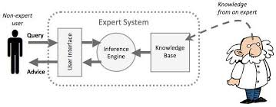

Following are Important characteristic of Expert System:

* **The Highest Level of Expertise:**The expert system offers the highest level of expertise. It provides efficiency, accuracy and imaginative problem-solving.
* **Right on Time Reaction:**An Expert System interacts in a very reasonable period of time with the user. The total time must be less than the time taken by an expert to get the most accurate solution for the same problem.
* **Good Reliability:**The expert system needs to be reliable, and it must not make any a mistake.
* **Flexible:**It is vital that it remains flexible as it the is possessed by an Expert system.
* **Effective Mechanism:**Expert System must have an efficient mechanism to administer the compilation of the existing knowledge in it.
* **Capable of handling challenging decision & problems:**An expert system is capable of handling challenging decision problems and delivering solutions.

**What is conference?**

A conference is a meeting of people who “confer” about a topic. conference can be:

* **Academic conference** in science and academic a formal event where researchers present results, workshops, other activities.
* **Business conference** organised to discuss business related matters
* **Conference call** in telecommunications, a multi-party cell.
* **Press conference** where an announcement is given to press. Etc.

For smooth Running of conference, meticulous planning must be carried out well in advance. All important aspects of the conference must be covered so that it is better to maintain check list.

Firstly, the purpose of the conference must be clearly understood. The budget needs to be defined. While some companies have sufficient large conference rooms to accommodate the event, an external venue is most commonly needed.

**Knowledge Base:**

A knowledge base is a database used for knowledge sharing and management.

It promotes the collection, organization and retrieval of knowledge. Many knowledge bases are structured around artificial intelligence and not only store data but find solutions for further problems using data from previous experience stored as part of the knowledge base.

Knowledge management systems depend on data management technologies ranging from relational databases to data warehouses. Some knowledge bases are little more than indexed encyclopaedic information; others are interactive and behave/respond according to the input prompted from the user.

A knowledge base is not merely a space for data storage, but can be an artificial intelligence tool for delivering intelligent decisions. Various knowledge representation techniques, including frames and scripts, represent knowledge. The services offered are explanation, reasoning and intelligent decision support.

Knowledge-based computer-aided systems engineering (KB-CASE) tools assist designers by providing suggestions and solutions, thereby helping to investigate the results of design decisions. The knowledge base analysis and design allow users to frame knowledge bases, from which informative decisions are made.

**Steps for organising conferences:**

**Step1:** Decide on a theme

**Step2:** Assemble your team

**Step3:** Prepare a budget and a business plan

**Step4:** Finding sponsors &grants

**Step5:** Settle on a date

**Step6:** Book the venue

**Step7:** Arrange catering and other vendors

**Step8:** Line up your speakers

**Step9:** Put together an agenda

**Step10:** Start registering attendees

**Step11:** Promote your conference

**Step12:** Take care of on-site planning

**Step13:** Host the conference

**Step14:** Follow up after the conference

**LITERATURE SURVEY:**

Existing literature is less and restricted to course specific workshops but not for general usage. The project “EXPERT SYSTEM FOR ORGANIZING CONFERENCES” is proposed in KLEF using Artificial intelligence in order to conduct general workshops related to any discipline.

**METHODOLOGY:**

The activities of the organization workshop is categorized into three different modules that are

* Pre-conference activities
* In-workshop activities
* Post-conference activities

In pre-workshop activities there will be doing registering organisers and registering student for workshop. Here constraint satisfaction problem are used for registering students for workshop since, he/she can register to an single workshop at a time and Depth First Search s(DFS) is used for conducting workshop only for more than 20 members since, we can’t afford so much money for bringing resource person for conducting workshop.

In In-workshop activities there will be taking attendance for the students who had attended for working for this we are using Back tracking using DFS since, the person who is present in first class he/she should be attend upto attend class so there will be taking attendance at starting and at ending.

In post-workshop activities there will be providing certificates and taking review from students and resource person. Constraint Satisfaction problem (CSP) is used in feedback from students since, student can give review only once and generally we say what we are doing at first time should be perfect.

**DFS Algorithm pseudocode:**

Function CONSISTENT (participant_count)

If participant_count<50

return FALSE

return TRUE

**Constraint Satisfaction Problem Pseudocode:**

Function CONSISTENT ()

If participant_exist==true

return FALSE

return TRUE

**IMPLEMENTATION:**

print(" WELCOME TO EXPERT SYSTEM ")

print(" -------------------------------------")

print(" THIS EXPERT SYSTEM IS USED TO ORGANIZE CONFERENCES ")

print(" ------------------------------------------------------------------")

a=[]

d=[]

print("DECIDE ON THEME")

print("1.TELECOMMUNICATIONS")

print("2.AUTOMOBILES")

print("3.ROBOTICS")

print("4.ARTIFICIAL INTELLIGENCE")

print("5.CYBER SECURITY")

print("Select a topic for conference")

n1=int(input())

if n1==1:

print("ASSEMBLE YOUR TEAM")

print("enter the no of team members for telecommunications")

n2=int(input())

print("Enter names of team members")

while(n2>0):

n3=input()

a.append(n3)

n2-=1

print("Your BUDGET for Organizing Conferenece")

n4=int(input())

u=0

sponsors={

"TELENOR":"10000-25000",

"MOBILINK":"25001-50000",

"UFONE":"50001-70000"

}

for x in sponsors:

r,l=sponsors[x].split("-")

r=int(r)

l=int(l)

if n4>=r and n4<=l:

u=1

print("This company is ready to sponsor your conference")

print(x)

spon=x

print("are you interested (Y/N)")

z=input()

if z=='N':

print(" OH! ITS GREAT YOU ARE A SELF SPONSOR")

else:

print("OK! COMPANY IS READY TO SPONSOR YOUR CONFERENCE")

if u==0:

print("No company sponsered")

print("enter the no.of days to organize this conference")

n5=int(input())

print("enter the starting date of the conference")

e=input()

print("choose your venue")

print("1.SUBHAM CONVENTIONS")

print("2.SIDDHARTHA GARDENS")

print("3.BANDLAMUDI GARDENS")

print("4.LIONS CLUB,GUNTUR")

f=int(input())

print("choose the catering")

print("1.ANNAPURNA CATERINGS")

print("2.RAMU CATERINGS")

p=int(input())

print("enter the no.of Speakers")

b=int(input())

print("LINE UP YOUR SPEAKERS")

while(b>0):

c=input()

d.append(c)

b-=1

print("----------------------------------------------")

print(" YOUR THEME IS TELECOMMUNICATIONS")

print("YOUR TEAM")

print(a)

print("BUDGET IS")

print(n4)

print("YOUR SPONSOR IS")

print(spon)

print("STARTING DATE OF CONFERENCE IS")

print(e)

print("VENUE FOR CONFERENCE IS")

if(f==1):

print("SUBHAM CONVENTIONS")

elif(f==2):

print("SIDDHARTHA GARDENS")

elif(f==3):

print("BANDLAMUDI GARDENS")

elif (f==4):

print("LIONS CLUB,GUNTUR")

else:

print("SORRY! NO VENUE")

print("CATERING FOR YOUR CONFERENCE IS")

if(p==1):

print("ANNAPURNA CATERINGS")

elif(p==2):

print("RAMU CATERINGS")

else:

print("NO CATERING")

print("YOUR SPEAKERS ARE")

print(d)

elif n1==2:

print("ASSEMBLE YOUR TEAM")

print("enter the no of team members for automobiles")

n2=int(input())

print("Enter names of team members")

while(n2>0):

n3=input()

a.append(n3)

n2-=1

print("Your BUDGET for Organizing Conferenece")

n4=int(input())

u=0

sponsors={

"TATA MOTORS":"10000-25000",

"MAHINDRA":"25000-50000",

"TOYOTA":"50000-70000"

}

for x in sponsors:

r,l=sponsors[x].split("-")

r=int(r)

l=int(l)

if n4>=r and n4<=l:

u=1

print("The company is ready to sponsor your conference")

print(x)

spon=x

print("are you interested (Y/N)")

z=input()

if z=='N':

print("OH! ITS GREAT YOU ARE A SELF SPONSOR")

else:

print("OK! COMPANY IS READY TO SPONSOR YOUE CONFERENCE")

if u==0:

print("No company sponsered")

print("enter the no.of days to organize this conference")

n5=int(input())

print("enter the starting date of the conference")

e=input()

print("choose your venue")

print("1.SUBHAM CONVENTIONS")

print("2.SIDDHARTHA GARDENS")

print("3.BANDLAMUDI GARDENS")

print("4.LIONS CLUB,GUNTUR")

f=int(input())

print("choose the catering")

print("1.ANNAPURNA CATERINGS")

print("2.RAMU CATERINGS")

p=int(input())

print("enter the no.of Speakers")

b=int(input())

print("LINE UP YOUR SPEAKERS")

while(b>0):

c=input()

d.append(c)

b-=1

print("----------------------------------------------")

print(" YOUR THEME IS AUTOMOBILES")

print("YOUR TEAM")

print(a)

print("BUDGET IS")

print(n4)

print("YOUR SPONSOR IS")

print(spon)

print("STARTING DATE OF CONFERENCE IS")

print(e)

print("VENUE FOR CONFERENCE IS")

if(f==1):

print("SUBHAM CONVENTIONS")

elif(f==2):

print("SIDDHARTHA GARDENS")

elif(f==3):

print("BANDLAMUDI GARDENS")

elif (f==4):

print("LIONS CLUB,GUNTUR")

else:

print("SORRY! NO VENUE")

print("CATERING FOR YOUR CONFERENCE IS")

if(p==1):

print("ANNAPURNA CATERINGS")

elif(p==2):

print("RAMU CATERINGS")

else:

print("NO CATERING")

print("YOUR SPEAKERS ARE")

print(d)

elif n1==3:

print("ASSEMBLE YOUR TEAM")

print("enter the no of team members for ROBOTICS")

n2=int(input())

print("Enter names of team members")

while(n2>0):

n3=input()

a.append(n3)

n2-=1

print("Your BUDGET for Organizing Conference")

n4=int(input())

u=0

sponsors={

"FETCH ROBOTICS":"10000-25000",

"GPS":"25001-50000",

"BLUE ROBOTICS":"50001-70000"

}

for x in sponsors:

r,l=sponsors[x].split("-")

r=int(r)

l=int(l)

if n4>=r and n4<=l:

u=1

print("The company is ready to sponsor your conference")

print(x)

spon=x

print("are you interested (Y/N)")

z=input()

if z=='N':

print("OH! ITS GREAT YOU ARE A SELF SPONSOR")

else:

print("OK! COMPANY IS READY TO SPONSOR YOUE CONFERENCE")

if u==0:

print("No company sponsered")

print("enter the no.of days to organize this conference")

n5=int(input())

print("enter the starting date of the conference")

e=input()

print("choose your venue")

print("1.SUBHAM CONVENTIONS")

print("2.SIDDHARTHA GARDENS")

print("3.BANDLAMUDI GARDENS")

print("4.LIONS CLUB,GUNTUR")

f=int(input())

print("choose the catering")

print("1.ANNAPURNA CATERINGS")

print("2.RAMU CATERINGS")

p=int(input())

print("enter the no.of Speakers")

b=int(input())

print("LINE UP YOUR SPEAKERS")

while(b>0):

c=input()

d.append(c)

b-=1

print("----------------------------------------------")

print(" YOUR THEME IS ROBOTICS")

print("YOUR TEAM")

print(a)

print("BUDGET IS")

print(n4)

print("YOUR SPONSOR IS")

print(spon)

print("STARTING DATE OF CONFERENCE IS")

print(e)

print("VENUE FOR CONFERENCE IS")

if(f==1):

print("SUBHAM CONVENTIONS")

elif(f==2):

print("SIDDHARTHA GARDENS")

elif(f==3):

print("BANDLAMUDI GARDENS")

elif (f==4):

print("LIONS CLUB,GUNTUR")

else:

print("SORRY! NO VENUE")

print("CATERING FOR YOUR CONFERENCE IS")

if(p==1):

print("ANNAPURNA CATERINGS")

elif(p==2):

print("RAMU CATERINGS")

else:

print("NO CATERING")

print("YOUR SPEAKERS ARE")

print(d)

elif n1==4:

print("ASSEMBLE YOUR TEAM")

print("enter the no of team members for ARTIFICIAL INTELLIGENCE")

n2=input()

n2=int(n2)

print("Enter names of team members")

while(n2>0):

n3=input()

a.append(n3)

n2-=1

print("Your BUDGER for Organizing Conference")

n4=int(input())

u=0

sponsors={

"CLOUD MINDS":"10000-25000",

"DEEP MIND":"25001-50000",

"AI BRAIN":"50001-70000"

}

for x in sponsors:

r,l=sponsors[x].split("-")

r=int(r)

l=int(l)

if n4>=r and n4<=l:

u=1

print("The company is ready to sponsor your conference")

print(x)

spon=x

print("are you interested (Y/N)")

z=input()

if z=='N':

print("OH! ITS GREAT YOU ARE A SELF SPONSOR")

else:

print("OK! COMPANY IS READY TO SPONSOR YOUR CONFERENCE")

if u==0:

print("No company sponsered")

print("enter the no.of days to organize this conference")

n5=int(input())

print("enter the starting date of the conference")

e=input()

print("choose your venue")

print("1.SUBHAM CONVENTIONS")

print("2.SIDDHARTHA GARDENS")

print("3.BANDLAMUDI GARDENS")

print("4.LIONS CLUB,GUNTUR")

f=int(input())

print("choose the catering")

print("1.ANNAPURNA CATERINGS")

print("2.RAMU CATERINGS")

p=int(input())

print("enter the no.of Speakers")

b=int(input())

print("LINE UP YOUR SPEAKERS")

while(b>0):

c=input()

d.append(c)

b-=1

print("----------------------------------------------")

print(" YOUR THEME IS ARTIFICIAL INTELLIGENCE")

print("YOUR TEAM")

print(a)

print("BUDGET IS")

print(n4)

print("YOUR SPONSOR IS")

print(spon)

print(" STARTING DATE OF CONFERENCE IS")

print(e)

print("VENUE FOR CONFERENCE IS")

if(f==1):

print("SUBHAM CONVENTIONS")

elif(f==2):

print("SIDDHARTHA GARDENS")

elif(f==3):

print("BANDLAMUDI GARDENS")

elif (f==4):

print("LIONS CLUB,GUNTUR")

else:

print("SORRY! NO VENUE")

print("CATERING FOR YOUR CONFERENCE IS")

if(p==1):

print("ANNAPURNA CATERINGS")

elif(p==2):

print("RAMU CATERINGS")

else:

print("NO CATERING")

print("YOUR SPEAKERS ARE")

print(d)

elif n1==5:

print("ASSEMBLE YOUR TEAM")

print("enter the no of team members for CYBER SECURITY")

n2=input()

n2=int(n2)

print("Enter names of team members")

while(n2>0):

n3=input()

a.append(n3)

n2-=1

print("Your BUDGET for Organizing Conference")

n4=int(input())

u=0

sponsors={

"SYMANTEC":"10000-25000",

"CHECK POINT":"25001-50000",

"CISCO":"50001-70000"

}

for x in sponsors:

r,l=sponsors[x].split("-")

r=int(r)

l=int(l)

if n4>=r and n4<=l:

u=1

print("The company is ready to sponsor your conference")

print(x)

spon=x

print("are you interested (Y/N)")

z=input()

if z=='N':

print("OH! ITS GREAT YOU ARE A SELF SPONSOR")

else:

print("OK! COMPANY IS READY TO SPONSOR YOUR CONFERENCE")

if u==0:

print("No company sponsered")

print("enter the no.of days to organize this conference")

n5=int(input())

print("enter the starting date of the conference")

e=input()

print("choose your venue")

print("1.SUBHAM CONVENTIONS")

print("2.SIDDHARTHA GARDENS")

print("3.BANDLAMUDI GARDENS")

print("4.LIONS CLUB,GUNTUR")

f=int(input())

print("choose the catering")

print("1.ANNAPURNA CATERINGS")

print("2.RAMU CATERINGS")

p=int(input())

print("enter the no.of Speakers")

b=int(input())

print("LINE UP YOUR SPEAKERS")

while(b>0):

c=input()

d.append(c)

b-=1

print("----------------------------------------------")

print(" YOUR THEME IS CYBER SECURITY")

print("YOUR TEAM")

print(a)

print("BUDGET IS")

print(n4)

print("YOUR SPONSOR IS")

print(spon)

print(" STARTING DATE OF CONFERENCE IS")

print(e)

print("VENUE FOR CONFERENCE IS")

if(f==1):

print("SUBHAM CONVENTIONS")

elif(f==2):

print("SIDDHARTHA GARDENS")

elif(f==3):

print("BANDLAMUDI GARDENS")

elif (f==4):

print("LIONS CLUB,GUNTUR")

else:

print("SORRY! NO VENUE")

print("CATERING FOR YOUR CONFERENCE IS")

if(p==1):

print("ANNAPURNA CATERINGS")

elif(p==2):

print("RAMU CATERINGS")

else:

print("NO CATERING")

print("YOUR SPEAKERS ARE")

print(d)

**RESULTS:**

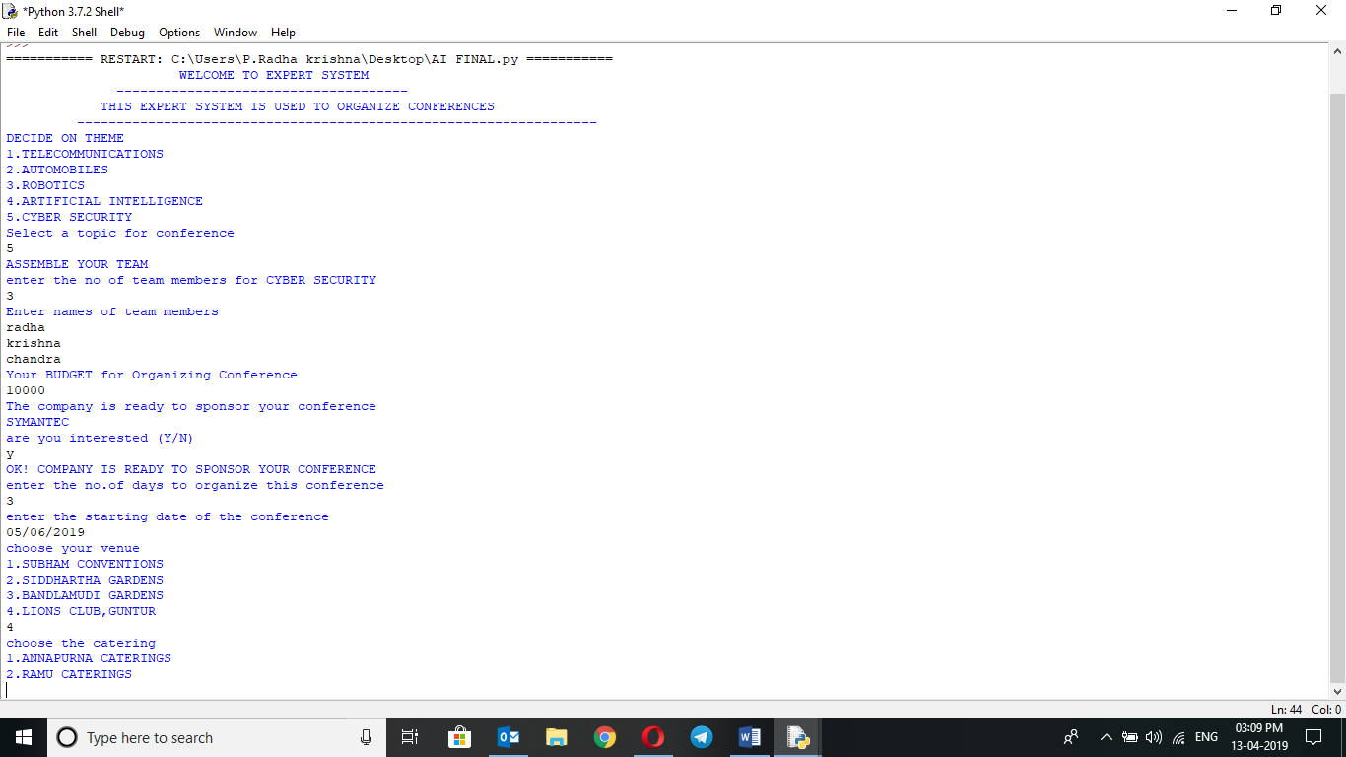

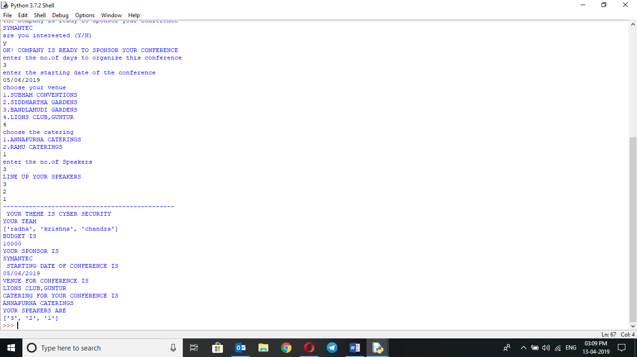

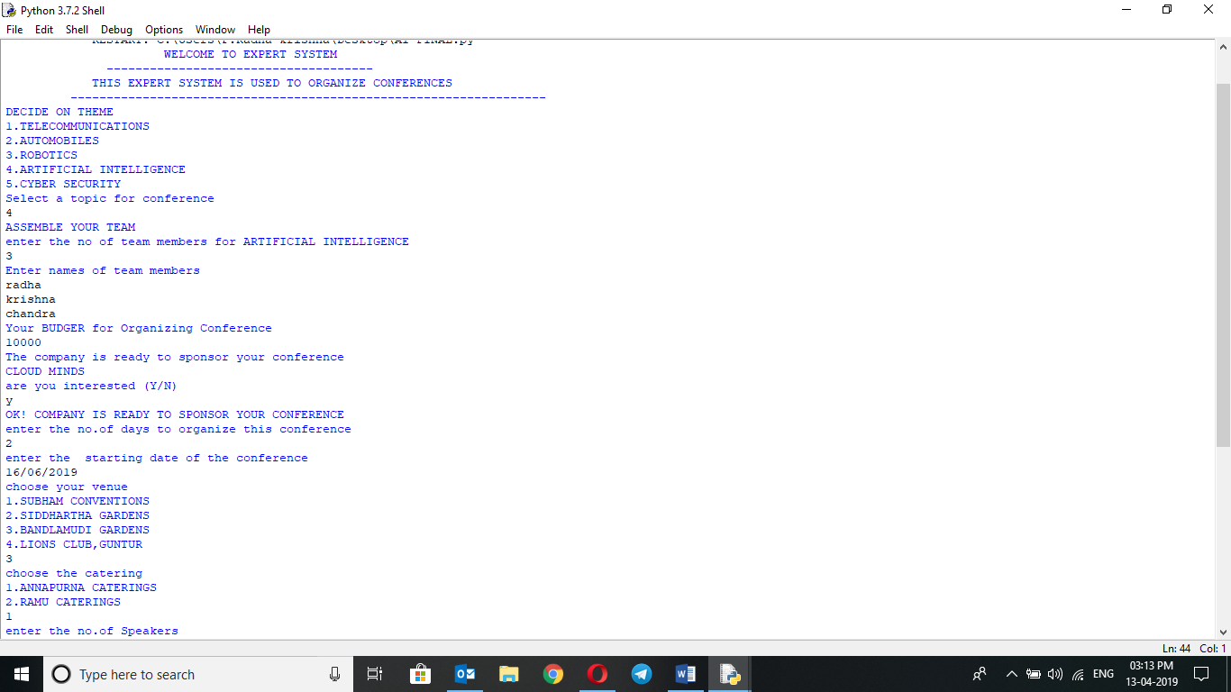

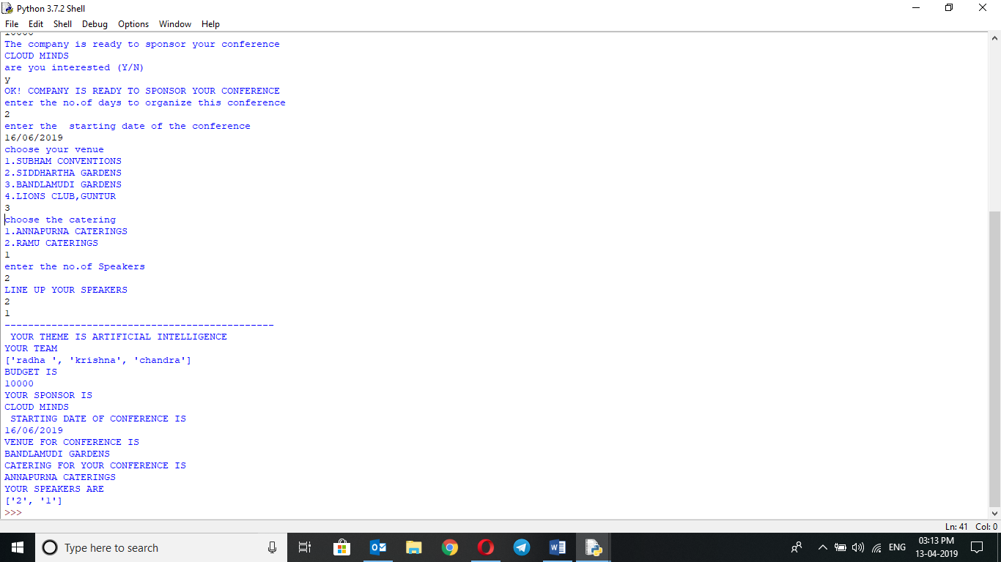

**CONCLUSION:**

In this project we implemented an expert system for organizing conferences. An expert system is an example of a [knowledge-based system](https://en.wikipedia.org/wiki/Knowledge-based_system). Expert systems were the first commercial systems to use a knowledge-based architecture. A knowledge-based system is essentially composed of two sub-systems: the [knowledge base](https://en.wikipedia.org/wiki/Knowledge_base) and the [inference engine](https://en.wikipedia.org/wiki/Inference_engine). Knowledge-based computer-aided systems engineering (KB-CASE) tools assist designers by providing suggestions and solutions, thereby helping to investigate the results of design decisions. The knowledge base analysis and design allow users to frame knowledge bases, from which informative decisions are made.

**REFERENCES:**

* 1. <https://www.tutorialspoint.com/artificial_intelligence/artificial_intelligence_expert_systems.htm>
  2. <https://www.geeksforgeeks.org/expert-systems/>
  3. <https://stackoverflow.com/questions/711893/expert-system-basics>
  4. <https://pyknow.readthedocs.io/en/stable/>